**CS342 – Operating Systems Lab**

**Lab 9**

Tarusi Mittal 1901CS65

**Question 1:** Write a C program to take the number of frames and page sequence as input and select the best page replacement algorithm among (FIFO, LRU, Optimal) based on the number of page faults occurred. For the selected page replacement algorithm, output the frame content at each time step t and also the number of page faults. First line of input is number of frames and second line the page sequence.

**Answer:**

**Compilation:**

g++ -o -P1_1 P1_1.cpp -> Fifo

g++ -o -P1_2 P1_2.cpp -> Lru

g++ -o -P1_2 P1_2.cpp -> Optimal

**Syntax:**

./P1

No of frames

Page Sequence

X -> (To stop taking input)

**Sample Input and Output Fifo:**

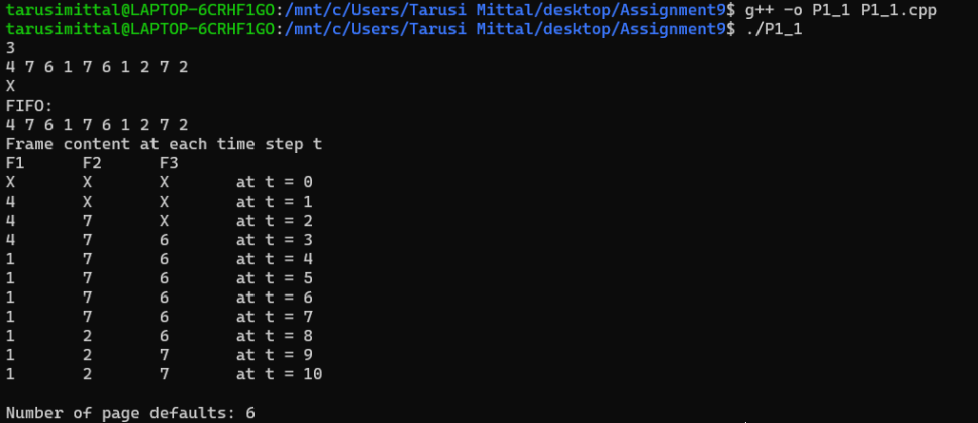

**Sample Input and Output Lru:**

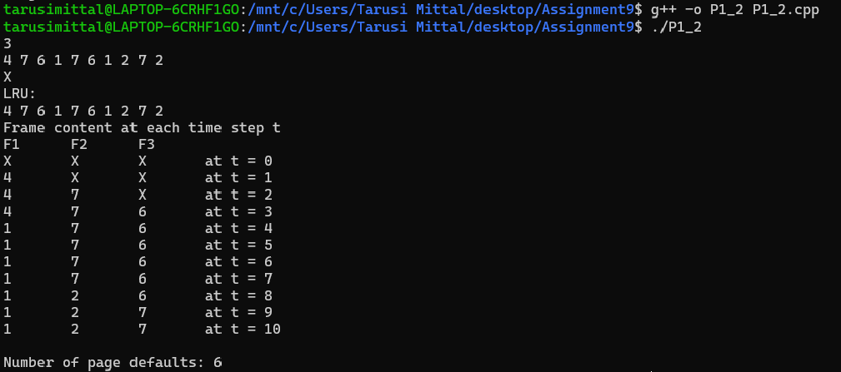

**Sample Input and Output Optimal:**

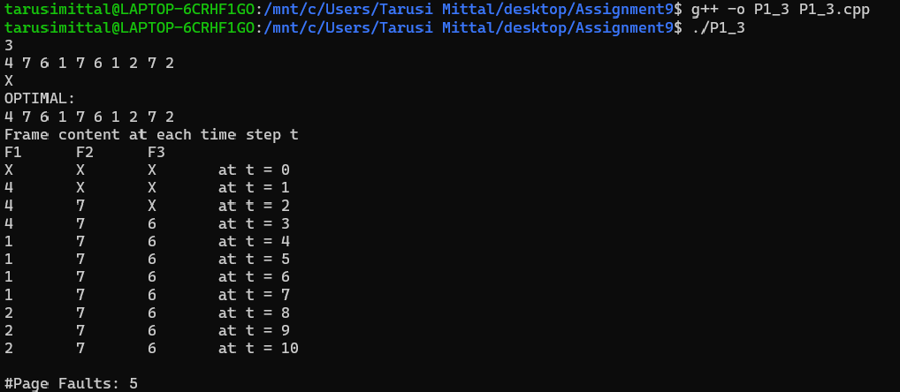

**Question 2:** Either modify the existing page replacement algorithm (FIFO, LRU, Optimal) or design unique page replacement algorithm in such a way that modified technique has less page faults when compared with FIFO, LRU and Optimal. Write a C code for the modified page replacement algorithm.

**Answer:**

We will first see for our new algorithm and then we will compare it with lru fifo and our optimal from previous question:

**Compilation:**

g++ -o -P2 P2.cpp

**Syntax:**

./P2

No of frames

Page Sequence

X -> (To stop taking input)

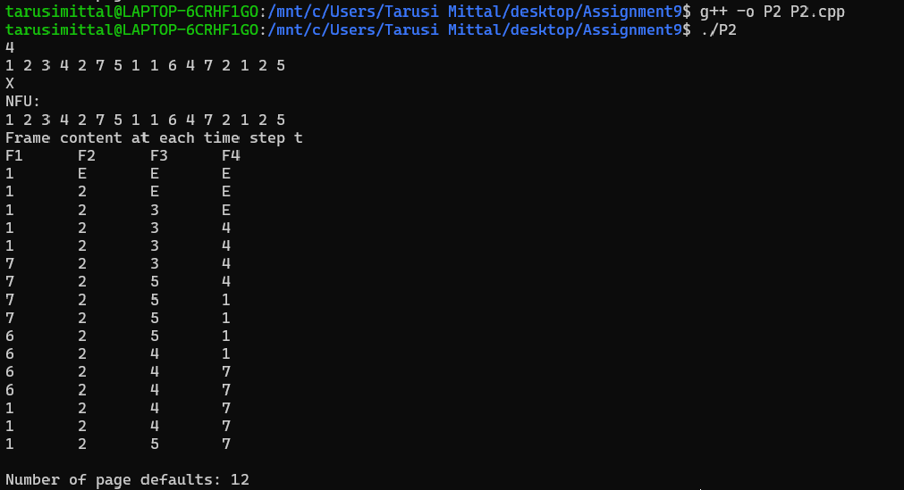

Now lets see for lru:

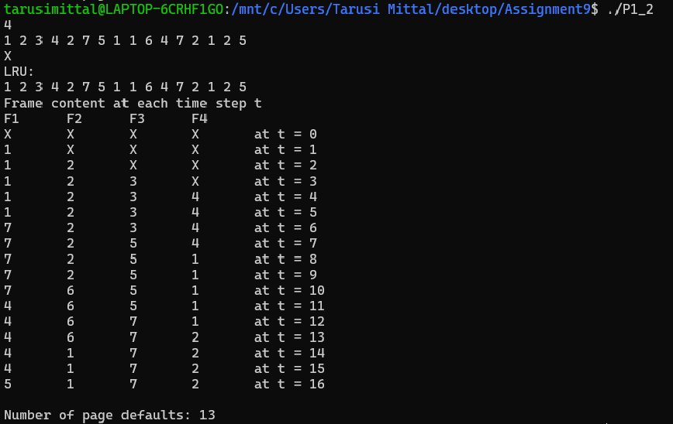

For fifo:

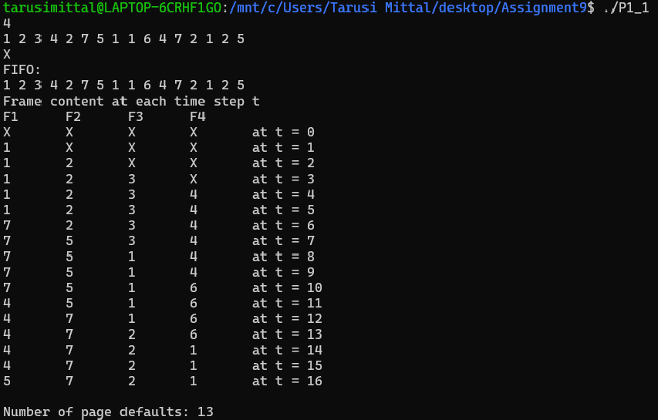

END